AutoEPID user guide

Table of Contents

1. Start Program 2

2. Patient EPID QA 3

IMRT QA 3

VMAT QA 6

Converting EPID image only 7

3. EPID calibration 10

4. Tips for common issues/trouble shooting 16

# Start Program

AutoEPID has two versions: clinical version and beta version. To run clinical version, go to Ctrix Application->Physics->AutoEPID

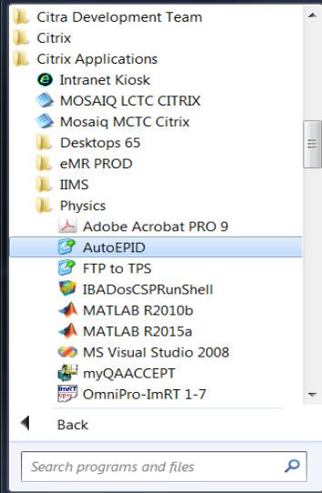

To start Beta version, go to Ctrix Application->Physics->Beta->AutoEPID

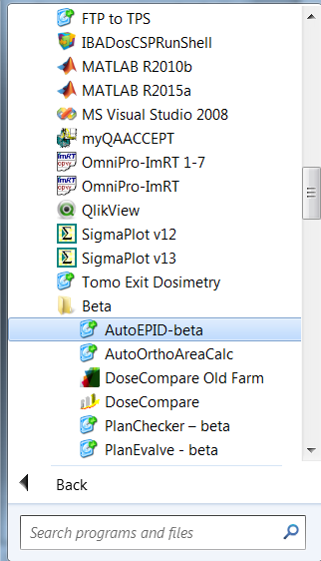

# Patient EPID QA

## IMRT QA

Use the following steps to analyze the patient EPID images for IMRT patient except breast IMRT.

1. Select patient from patient list. Select treatment, registration type and output option. Then click button **“Beam auto-Matching & Auto-Report”.**

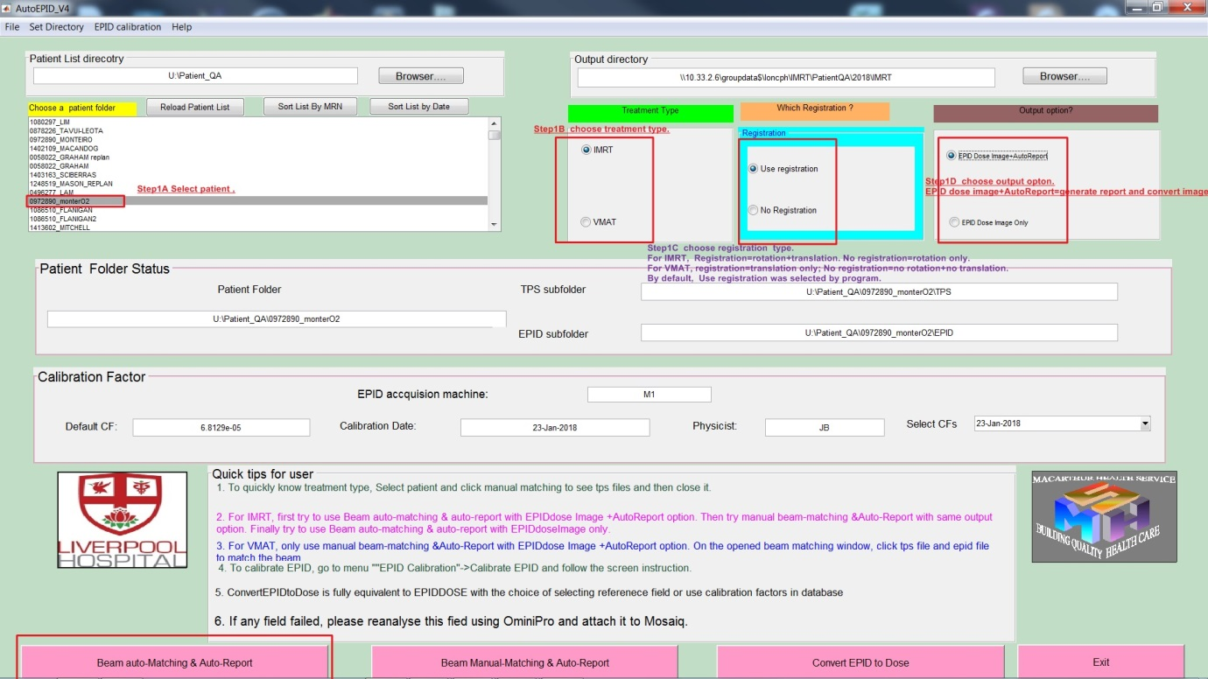

1. Choose patient log file from patient folder.

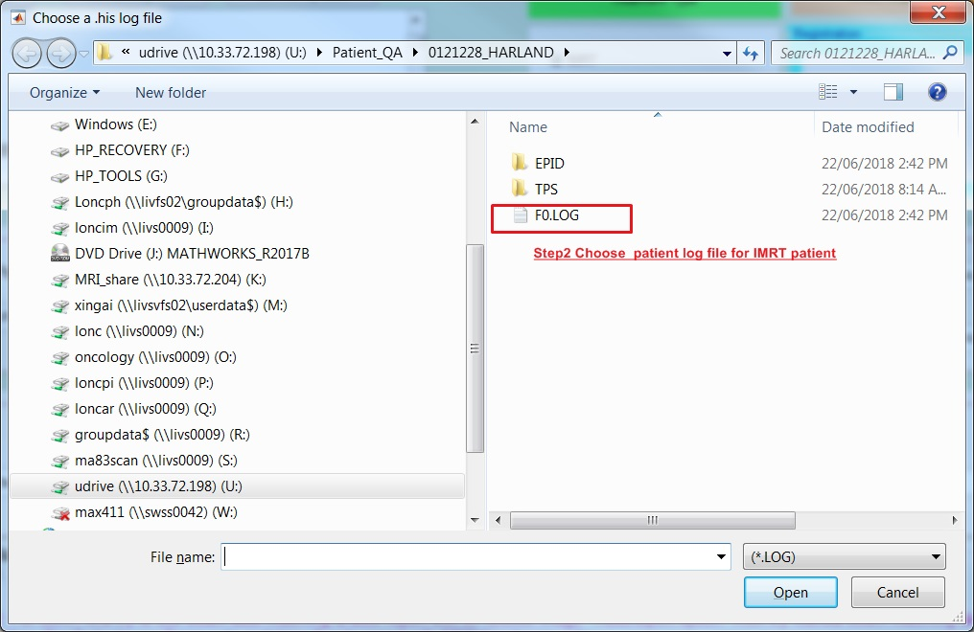

1. Choose DICOM template file from patient folder. The program will automatically calculate gamma map and generate a PDF report.

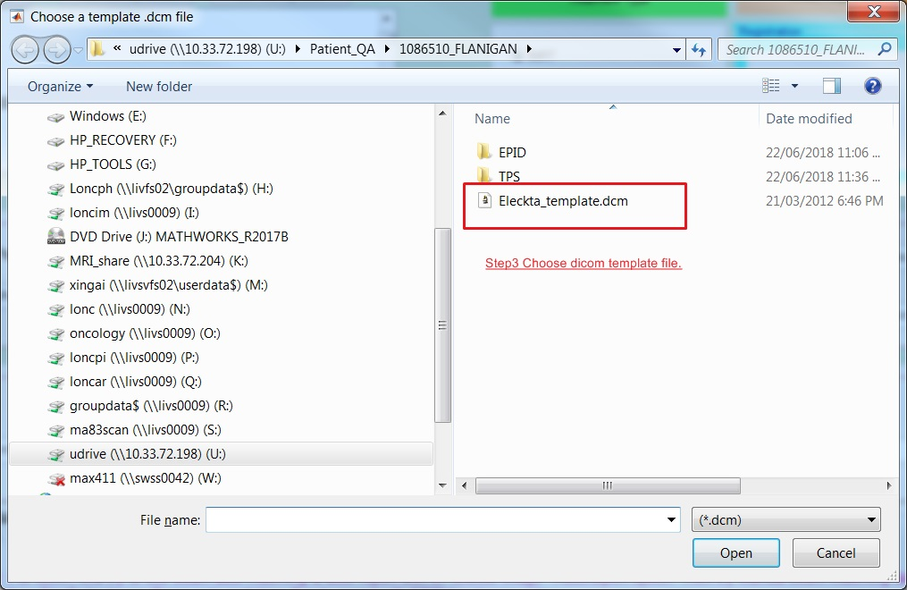

1. When the auto - analysis is finished, a pdf report will be written to S:\escan\MedPhys.

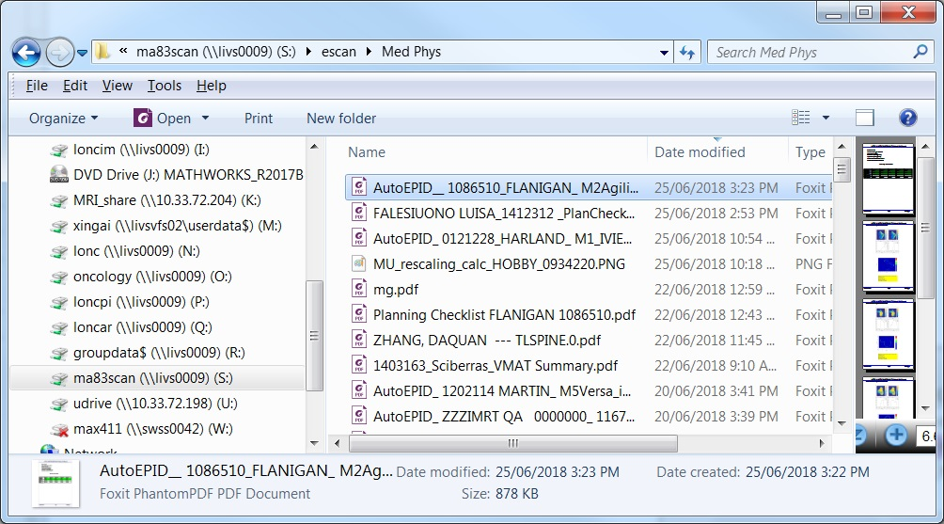

## VMAT QA

For VMAT patient and breast IMRT patient, the EPID images are analyzed through manual matching the EPID image and corresponding TPS files as shown below.

1. Same as the first step for IMRT patient EPID QA except changing the treatment type to VMAT, then click button **“Beam Manual-Matching & Auto-Report”.**

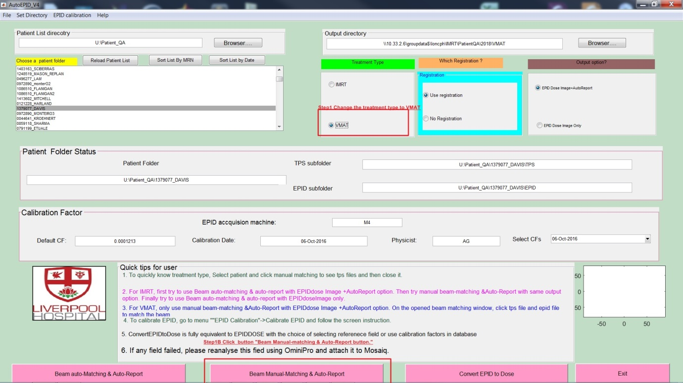

1. Click TPS and EPID file from TPS and EPID file list to match the files using the TPS and EPID dose image. Then move the matched TPS and EPID file into the matched TPS and EPID file list. Then click the button button “Generate autoReport EPID dose”.

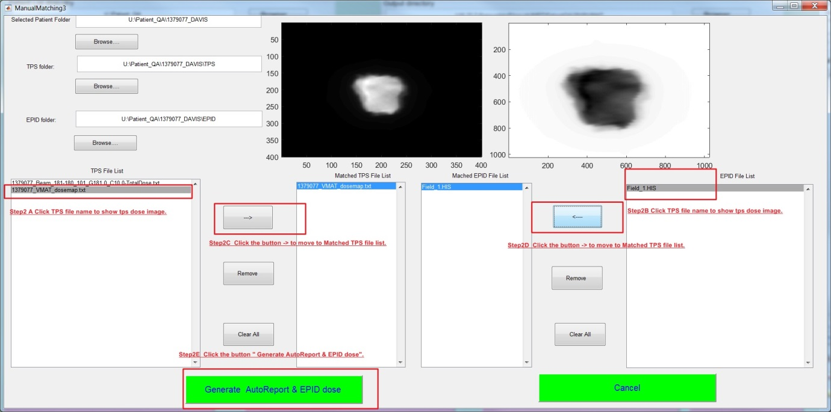

1. The rest of steps are same as steps 2 to 4 for IMRT patients

## Converting EPID image only

Patient EPID images can also be converted into dose image without performing profile and Gamma map analysis using calibration factors stored in the database or new acquired calibration EPID image.

1. Same as IMRT first step and just change the output option to **“EPID Dose Image only”.**

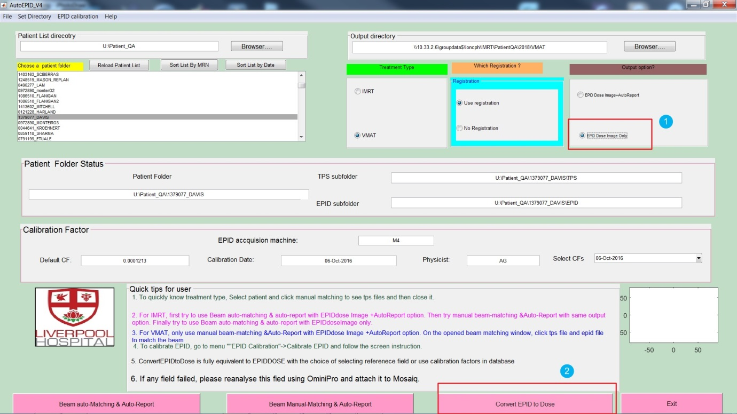

1. Choose yes if a calibration EPID image was acquired.

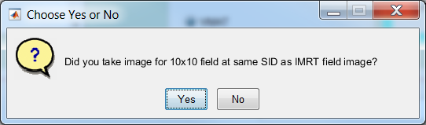

1. If Yes, choose the calibration images from the location where it was stored.

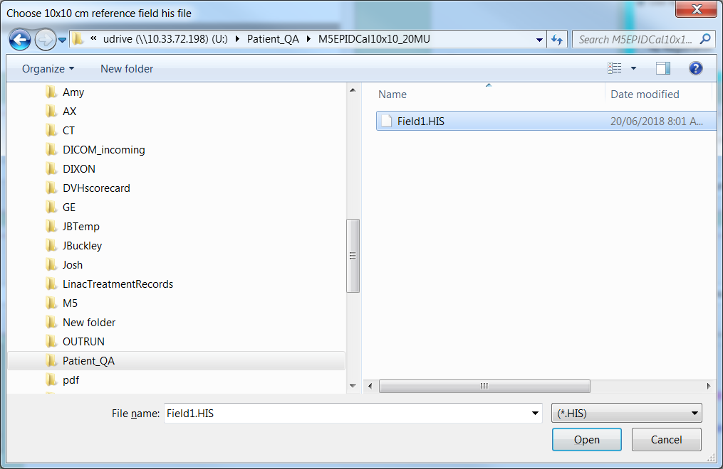

1. Choose the log file for calibration EPID image.

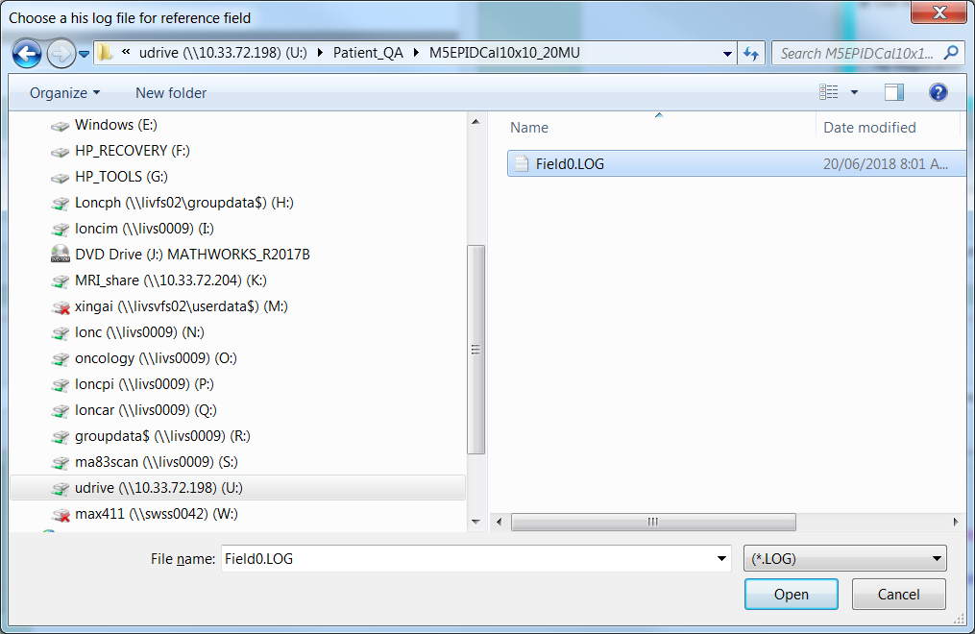

1. Enter the MUs used for acquiring calibration EPID image.

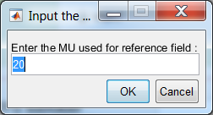

1. Choose patient log file.

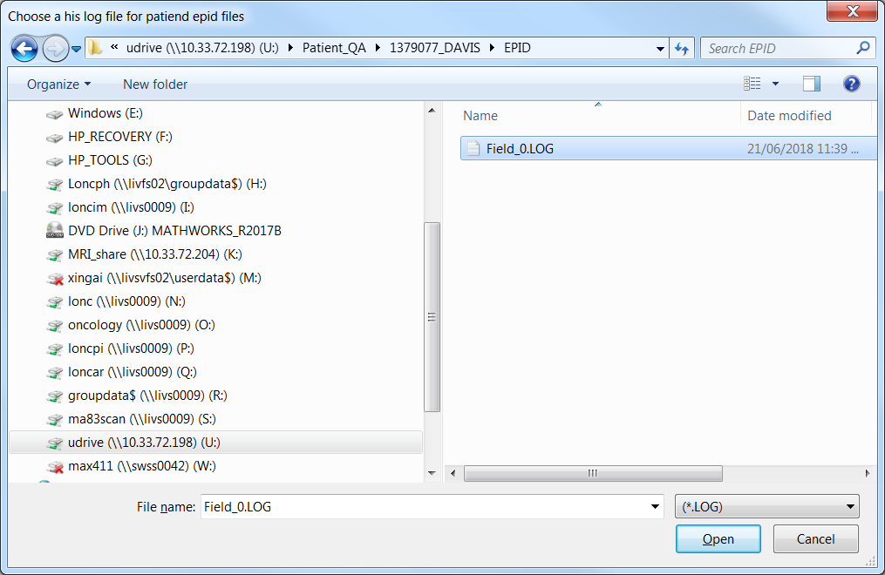

1. Choose a DICOM template for this patient. The program will convert EPID images into dose image and write them into patient folder.

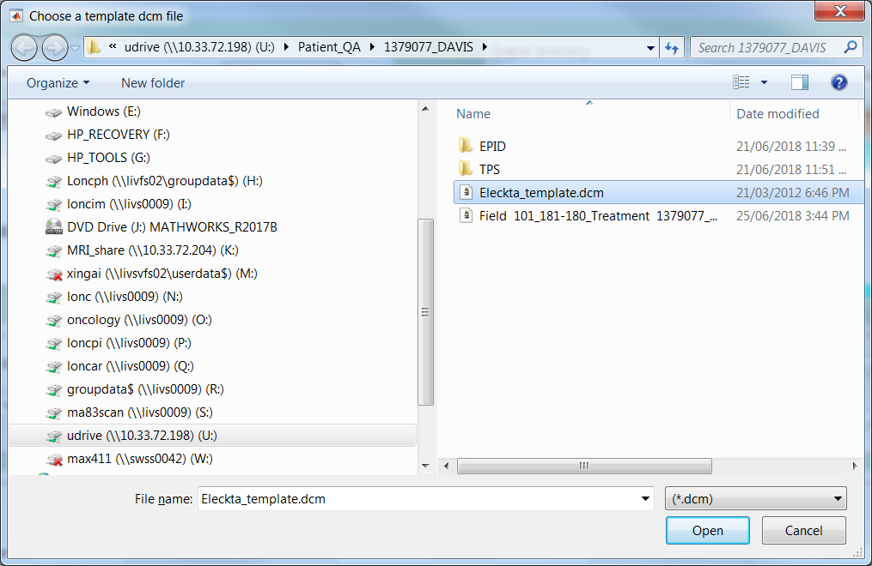

1. If No was selected, the rest of steps are same as step 13 and 14.

# EPID calibration

Before running the program, deliver 20 MU to EPID image using 10x10 field size. Export the EPID image and log file to a location on network driver such as U:\Patient_QA. The following procedure supposes EPID and log files were saved in U:\Patient_QA\M5EPIDCal10x10_20MU.

1. Click the user menu “**EPID Calibration”** and then choose **“Calibrate EPID”.**

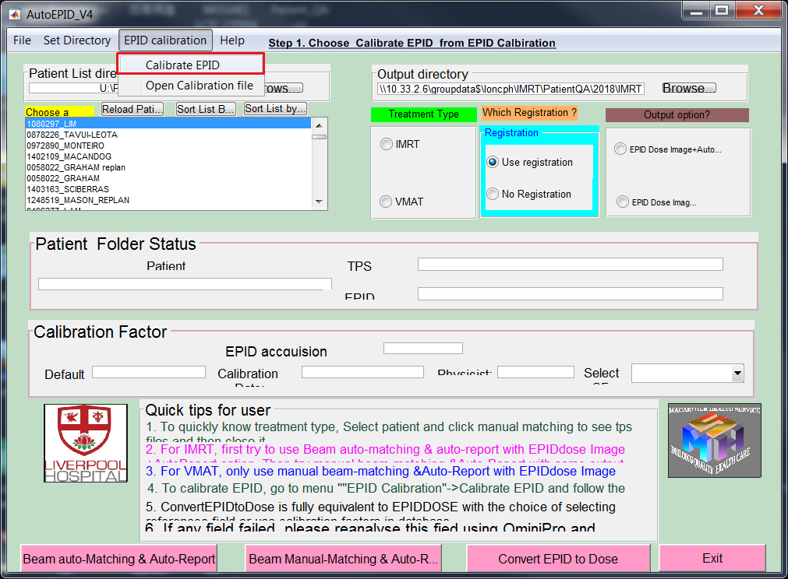

**2.** Choose the machine name, beam type and the physicist, and then click the button **“Browser”** to open the EPID image.

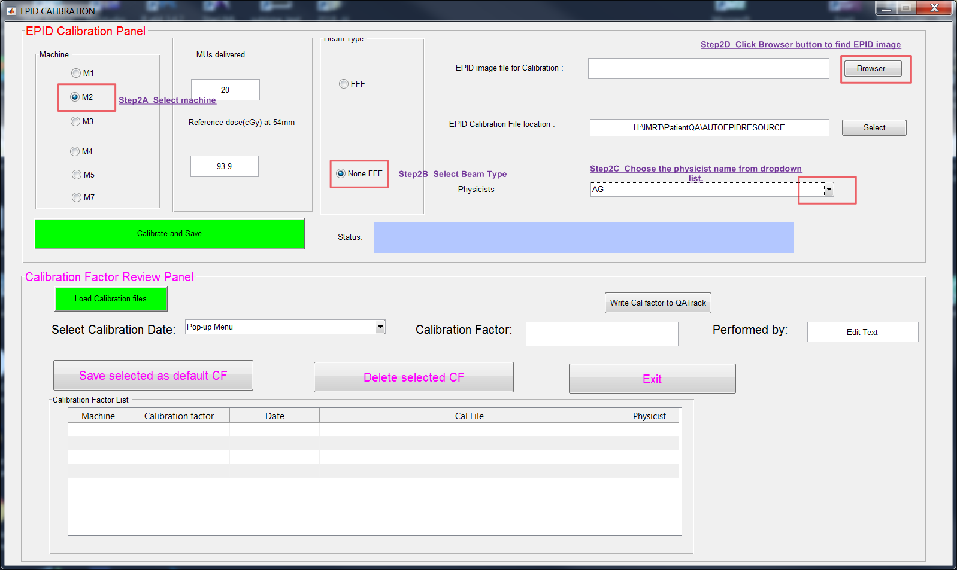

3. Select EPID image from where you saved.

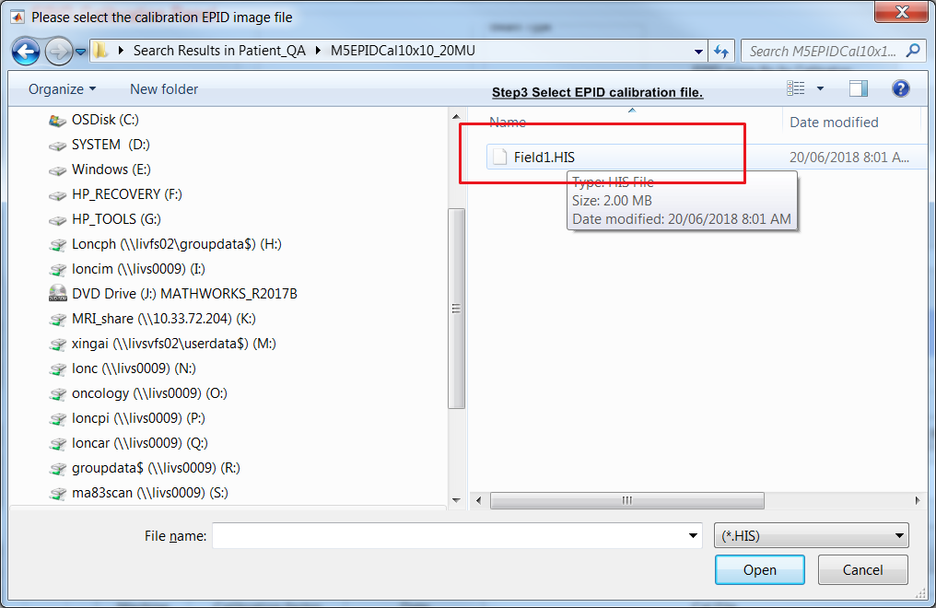

4. Click the button **“Calibrate and Save”.**

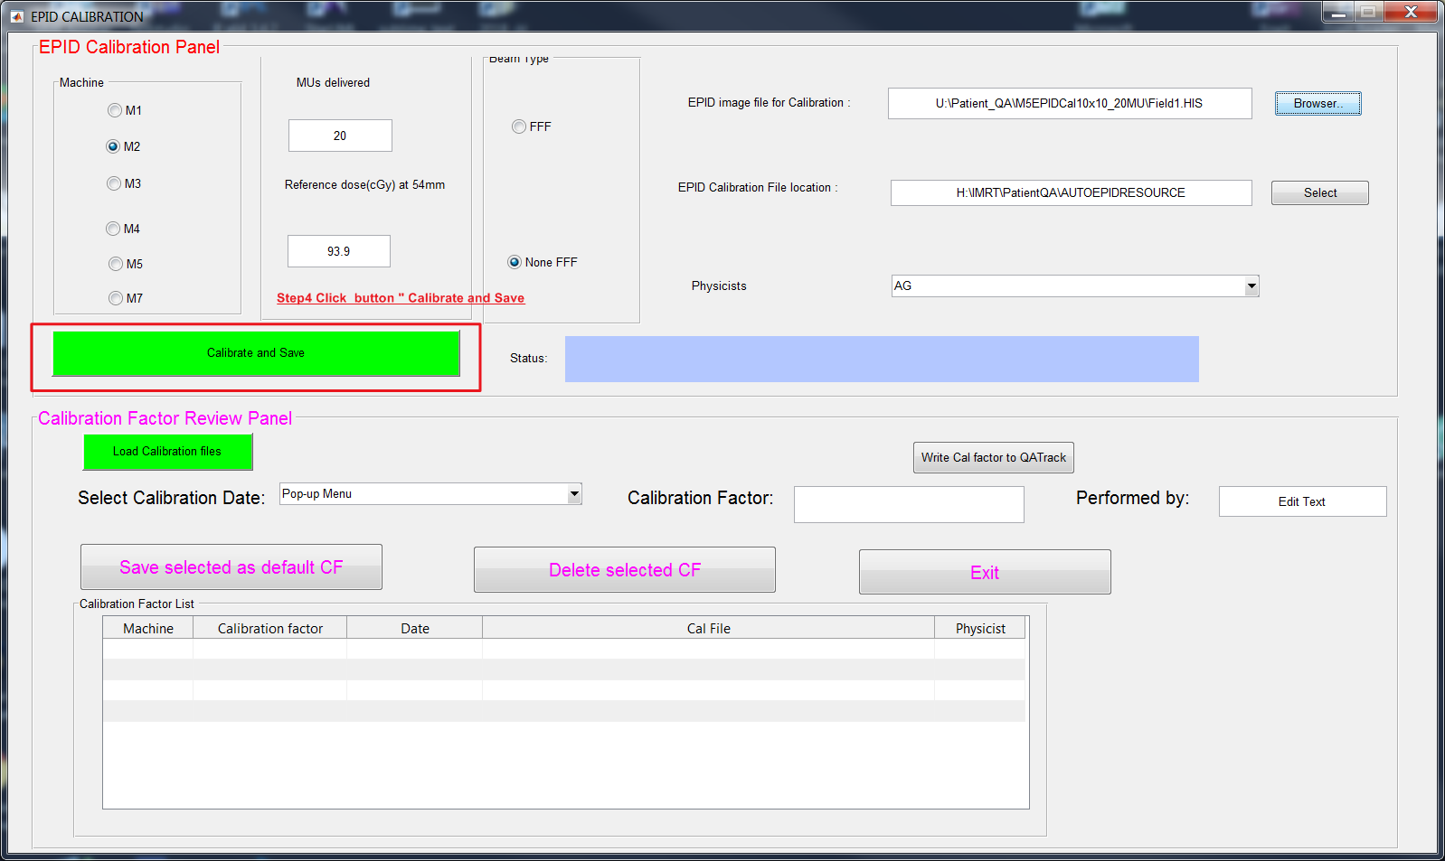

5. If the calibration is successful, a message will pop up in the status bar.

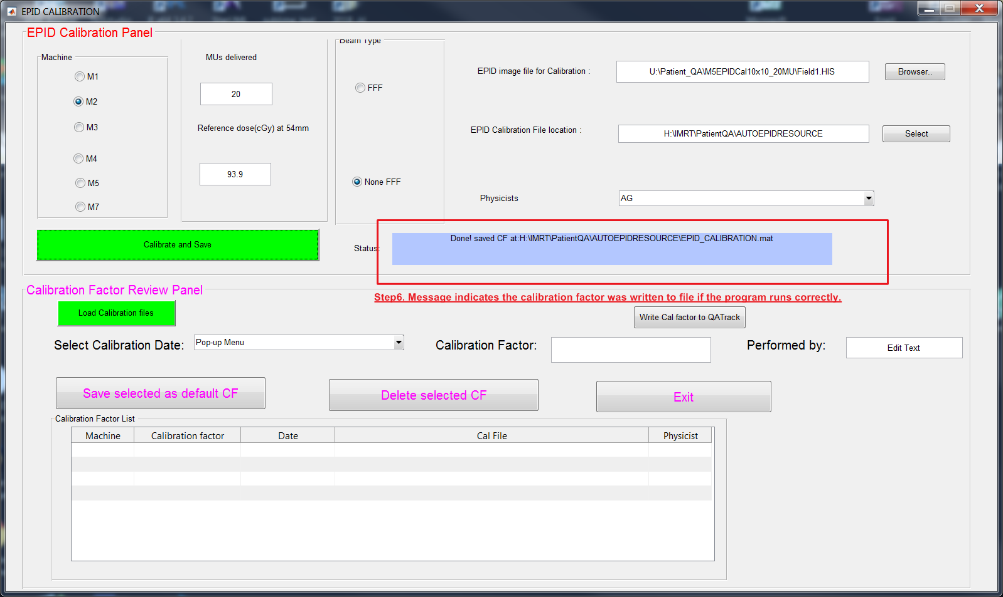

6. To view all calibration history or view the new added factor, click button “Load and Save”.

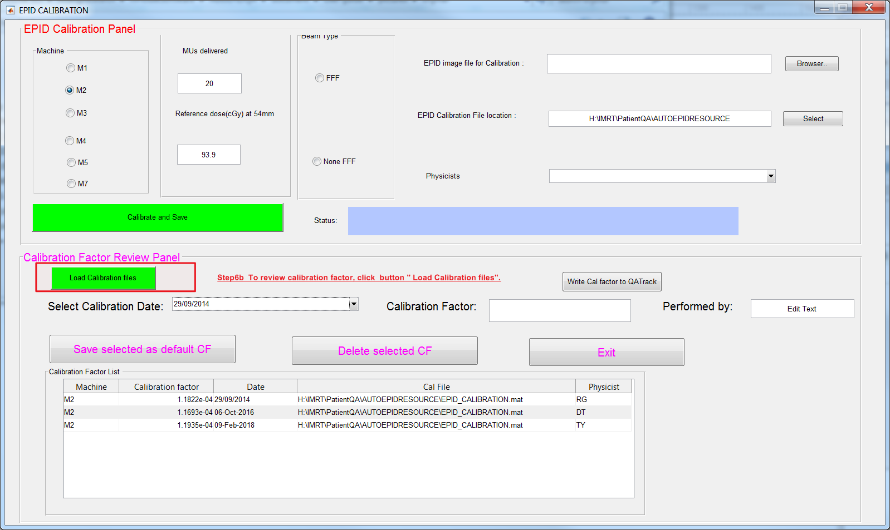

7. Select the calibration file sitting in **H:\IMRT\PatientQA\AUTOEPIDRESOURCE**.

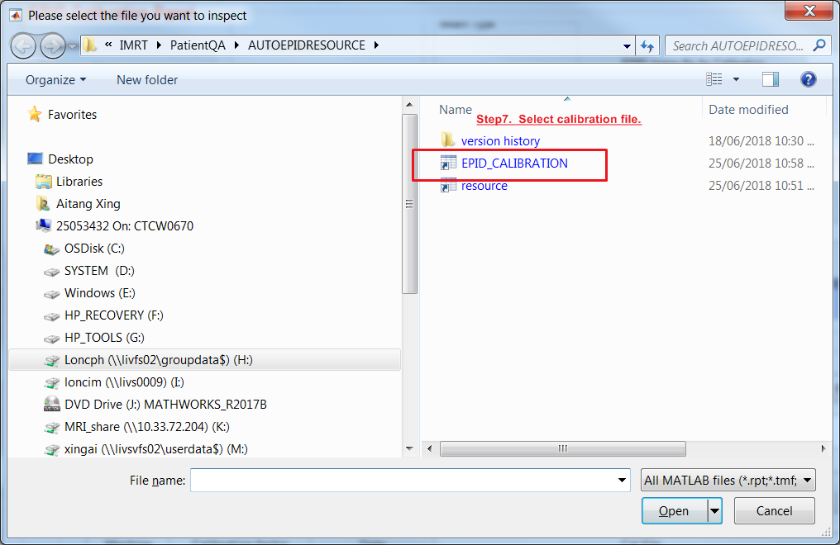

8. New added calibration factor was shown up in the table and the pop-up list.

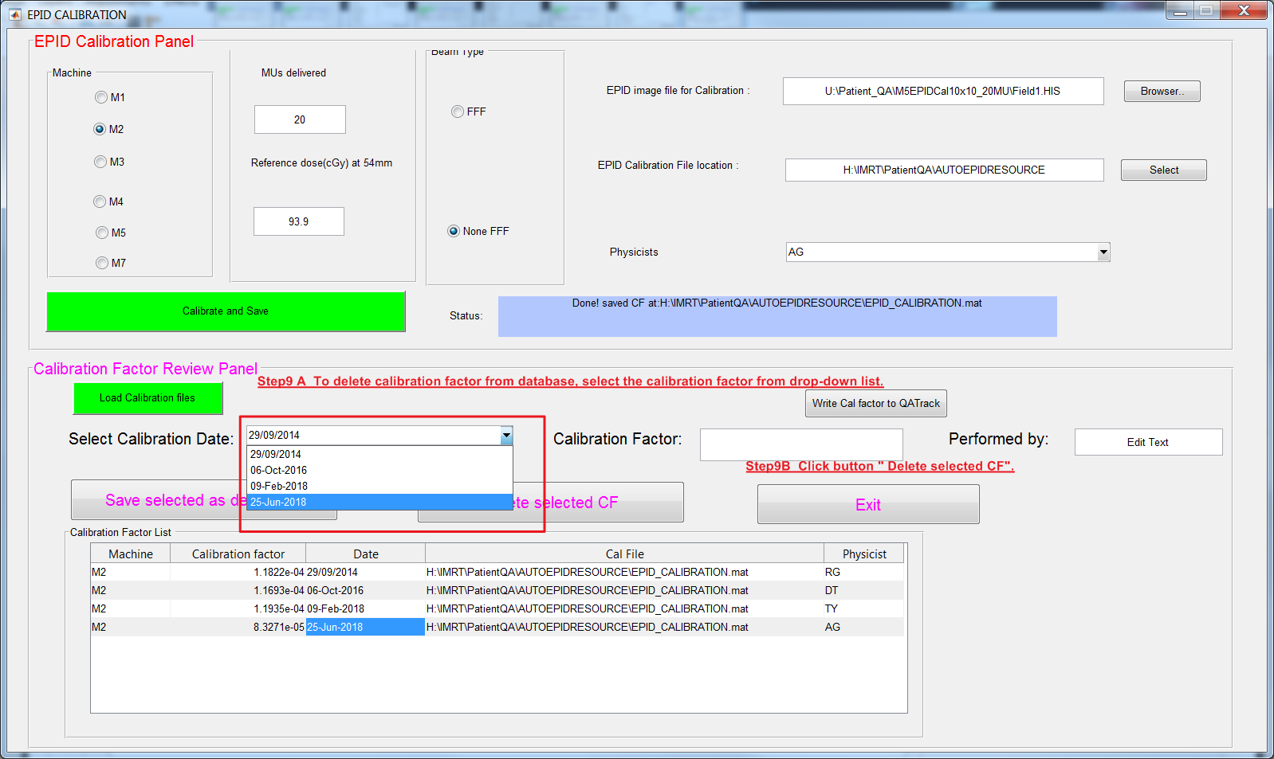

9. Any calibration factor can be deleted by choosing a calibration date from the drop list and then click button **“Delete selected CF”.**



10. To see if the calibration factor was deleted, reload the calibration file.

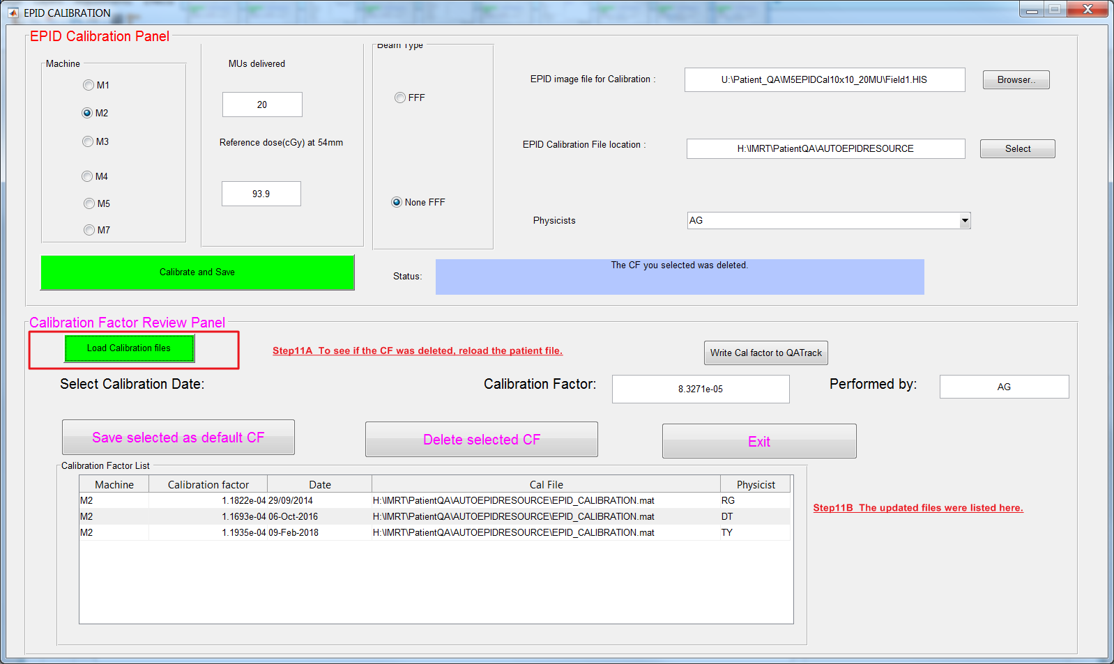

11. To set any calibration factor to be default factor, first select the factor from dropdown list and then click button **“Save selected as default CF ”.**

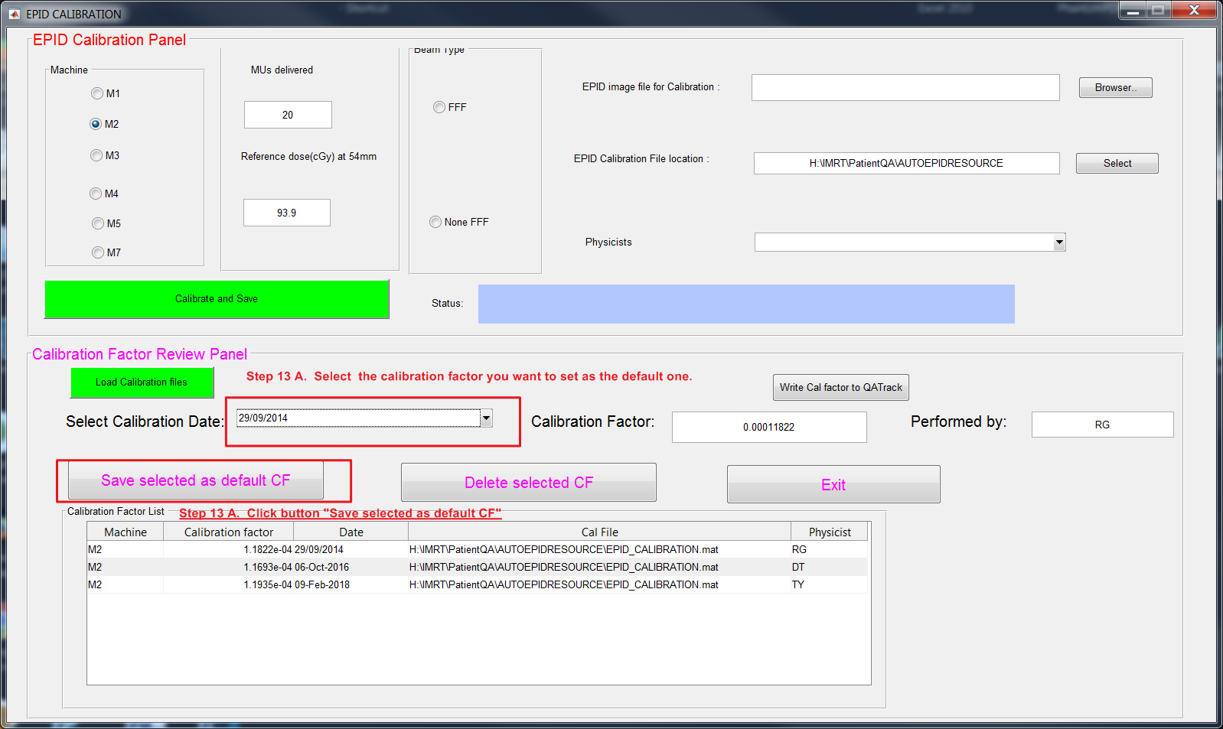

# 4. Tips for common issues/trouble shooting

If the program is not able to perform analysis for patient QA, the following steps outline the common issues.

1. Check if the patient folder contains two sub-folders: EPID and TPS.

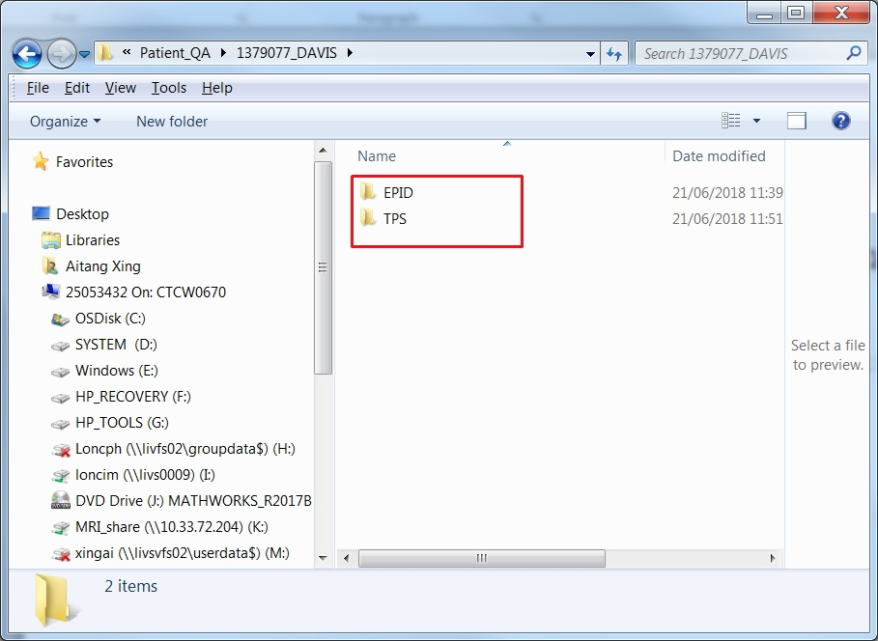

1. Open the log file to check if the path and EPID his file name matches where the actual location and file name. If it does not match, then change the path and file name in log file.

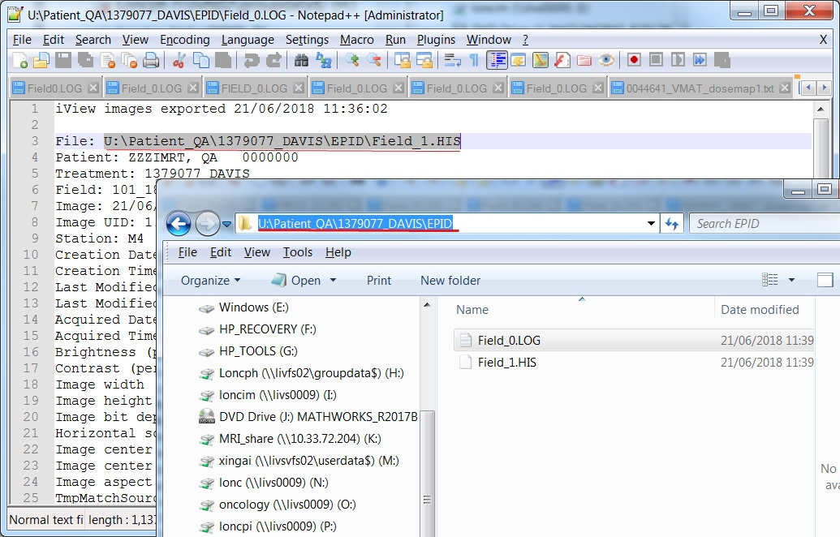

1. Open the log file to check Field label. For auto-matching, the field should be labelled as gantry angle or staring with G or g, for example, G181 or 181 or g181. Any other special character such as ‘/’, “”, # are not allowed to be used. The special character should be removed before running the program.

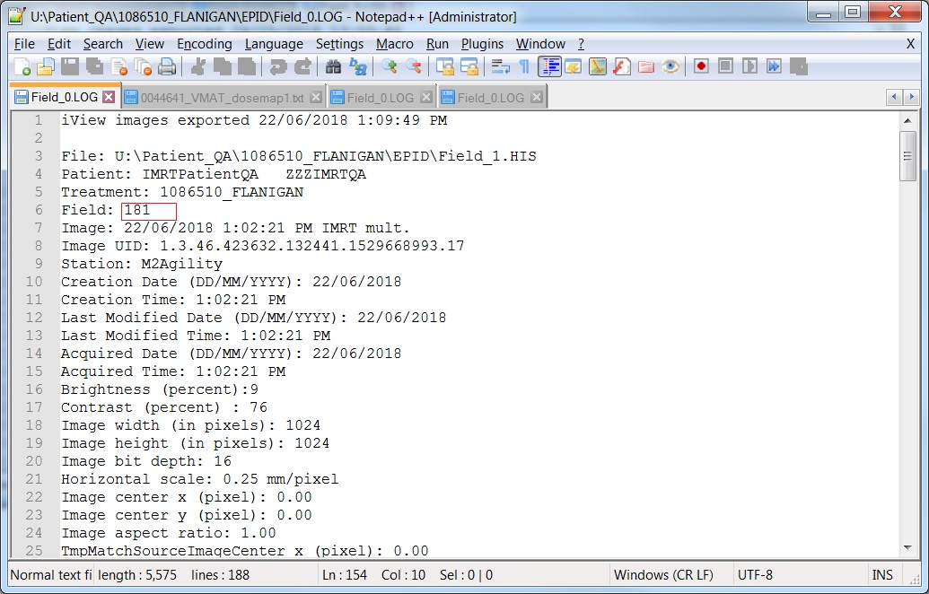

1. Check if the EPID image file size is 2049KB. If the file size is less than 2049K, the EPID image need to be redelivered.

